
phgy311
lecture #: | date: | professor:
28 | Nov. 22, 2006 | Dr. Farookhi
29  30 | Nov. 24, 2006  Nov. 27, 2006 | Dr. Farookhi  Dr. Farookhi
announcements:
- Physio Ski Trip Jan. 19-21 at Mont. Ste Anne!! It’s a great party and sometimes you manage to get some skiing in too, so come sign up in the PULS lounge soon because spots are limited!
- Look for posts on WecCT about when the final NTC set will be out
- Good luck on exams!

Edited By: Steph Rolin
Do Not Redistribute.
set #10
PHGY 311 - Lecture 28 November 22, 2006
Writer: Katie Turnbull Dr. Farookhi

SEXUAL DIFFERENTIATION
- The androgen receptor can bind both testosterone and DHT, although it binds DHT with a much greater affinity.
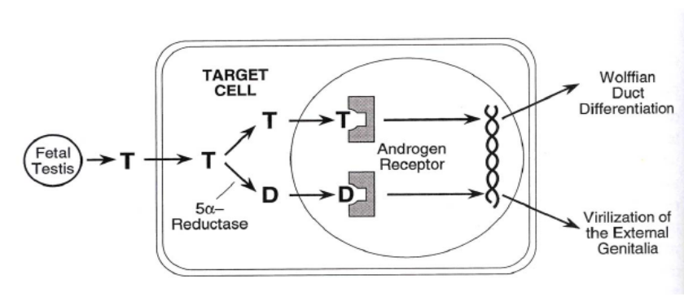

- If a male fetus lacks DHT, it will not develop properly. Testosterone causes Wolffian duct differentiation, but DHT is necessary for virilization of the external genitalia.
  - Individuals who lack 5α-Reductase will not be born with properly differentiated male external genitalia. They will be mistaken as female. Only at puberty, when the concentration of testosterone increases dramatically, will they begin to develop male external genitalia.

- Individuals who lack androgen receptors have testicular feminization syndrome
  - Chromosomal and gonadal sex are both present, as the individual is XY and has the SRY gene. However, the Wolffian duct is unable to be maintained and degenerates.
  - In addition, the Mullerian duct also degenerates due to MIS.
- The external genitalia of this individual will be female.
- It is important to note that the effect twill be the same whether the receptor is missing or whether the ligand is missing.

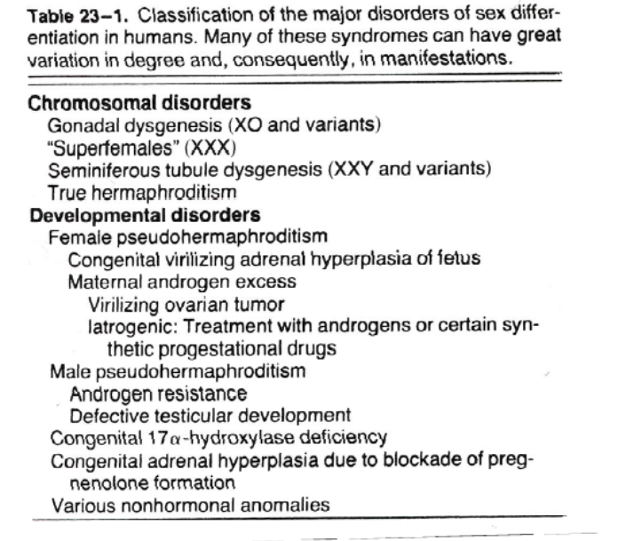
- At this point you should be able to understand what is happening in the case of each of the disorders in table 23-1, in the notes.
  - We have not covered congenital adrenal hyperplasia but it is in the textbook.

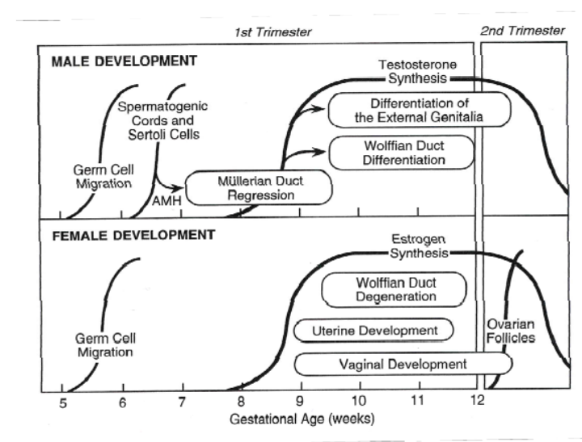
- The diagram on the left shows the timing of male development, relative to female development.
  - Recall: the female pathway is the default pathway. Everything that has to occur during male development has to occur EARLIER than in the female, otherwise female development will automatically occur.

PHENOTYPIC SEX DIFFERENTIATION

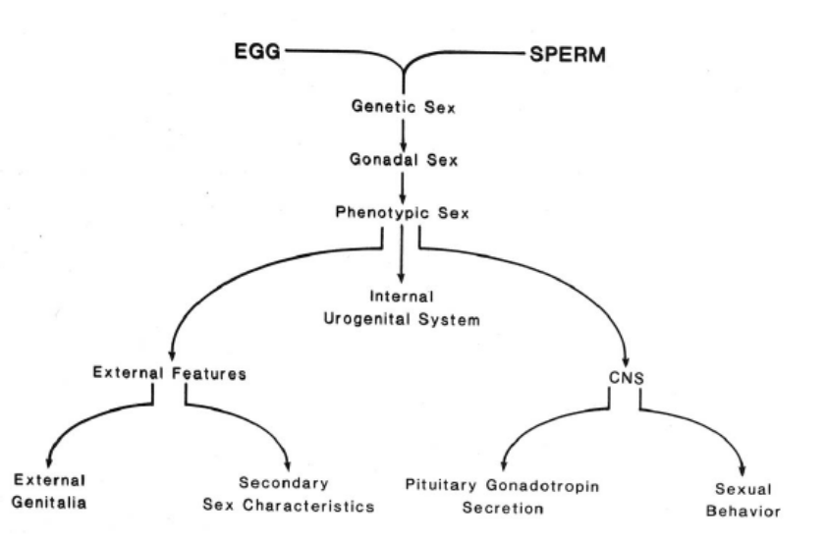
- We’ve seen the process by which genetic sex and gonadal sex are chosen and differentiated.
- Phenotypic sex differentiation involves internal & external genitalia differentiation as well as sex-specific CNS differentiation.
- The CNS needs to be differentiated to give rise to the different sexual behaviors in men and women.
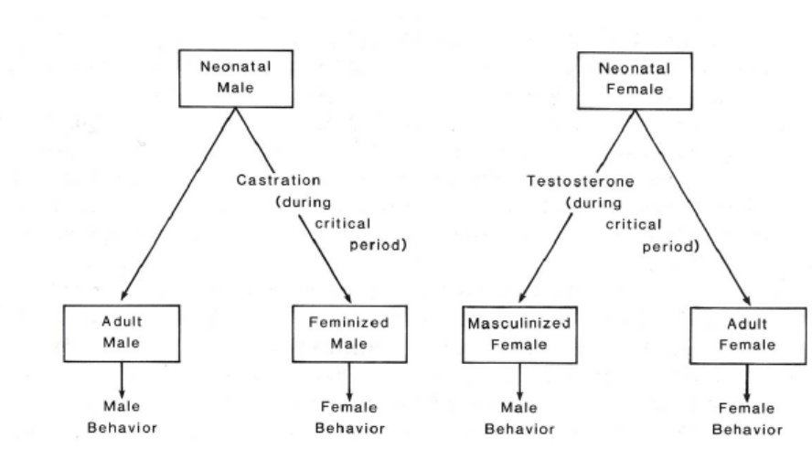

- In rats and mice, CNS sex differentiation occurs 3-5 days after birth.
  - It is possible to manipulate the CNS sex differentiation in these animals.
  - In humans, this occurs prior to birth.

- A man named Gorski did a series of experiments on neonatal male and female mice.
  - The two control groups were male and female mice that were allowed to develop normally. In these groups, the adult male showed male behavior, and the adult female showed female behavior.
  - One group of neonatal males was castrated before CNS sex differentiation occurred. As a result, Gorski observed feminized males, males showing female behavior.
    - Concluded that something in the testes was giving rise to male behavior.
  - A group of neonatal females were injected with high doses of testosterone during the critical period of CNS sex differentiation. The result was a group of masculinized females, females showing male behaviors.
    - Concluded that testosterone is the agent affecting CNS sex differentiation.

- In another experiment, Gorski injected neonatal female mice with DHT. Interestingly, these adult female mice showed female behavior.
  - It is estradiol acting in the brain that causes CNS sex differentiation.
    - In females, estradiol in the bloodstream is attached to an alpha fetoprotein which prevents it from crossing the blood-brain barrier.
    - In the male, testosterone can enter the brain and be easily converted to estradiol via aromatase.
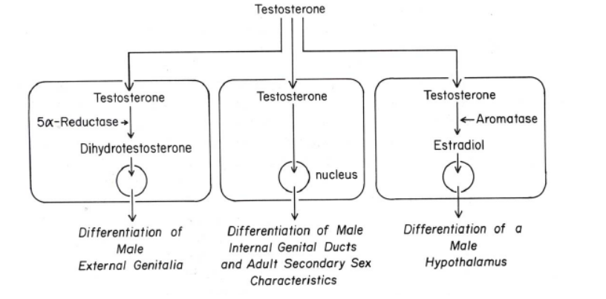
    - DHT cannot be converted into estradiol, so it cannot cause CNS sex differentiation.

SUMMARY OF TESTOSTERONE ACTION IN MALE
- Testosterone develops the Male external genitalia when it is converted to DHT.
- Testosterone affects the differentiation of the male internal genital ducts and secondary sex characteristics.
- Testosterone is converted to estradiol in the brain which leads to a male hypothalamus.

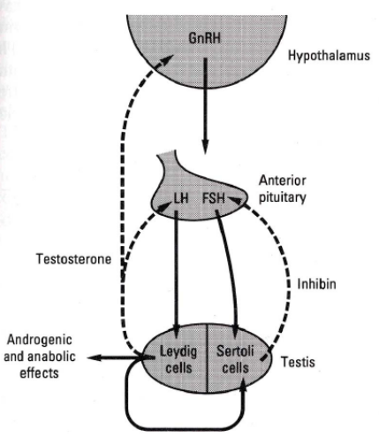
THE HYPOTHALAMO-HYPOPHYSIAL TESTICULAR AXIS
- Male reproduction is reliant on three major components:
    - The Hypothalamus
    - The Anterior Pituitary
    - The Testis (Leydig/Sertoli Cells)
  - The Leydig cells produce androgen which negatively feeds back on the Anterior Pituitary and the hypothalamus.
  - Sertoli cells produce inhibin which negatively feeds back on the Anterior Pituitary.
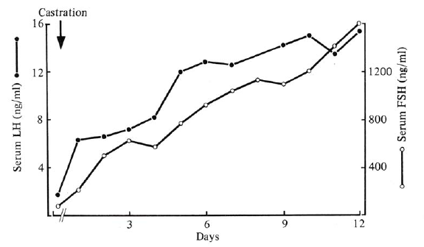
- If the testes are removed, the levels of LH, FSH, and GnRH will all rise, as they are no longer opposed by any feedback mechanisms.
  - Note the effect of castration on the graph to the right.
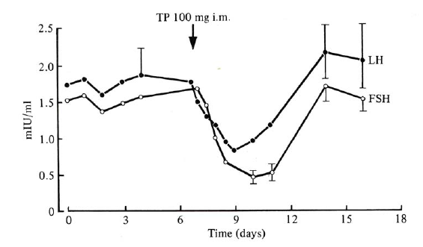
- However, if you inject a castrated individual with testosterone, the levels of LH, FSH, and GnRH will decrease as feedback will be temporarily restored.
  - Note the effect of an injection of testosterone.

SPERMATOGENESIS
- The epididymus and vas deferens are derived from the Wolffian Duct.
- The seminiferous tubule is a long continuous duct, about 500 meters long.
  - Within the tubules are the Sertoli cells, and external to the tubules are the Leydig cells.
- Male germ cells differentiate and multiply in the seminiferous tubules.
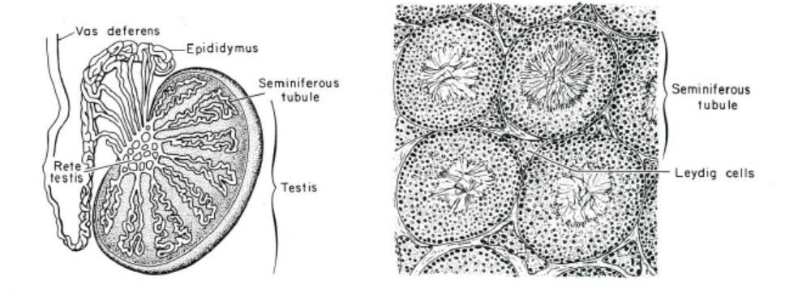
- Spermatogenesis is the production of sperm. Males are capable of producing sperm throughout their entire lives, as the stem cells in the testes allow males to create sperm cells.
  - This occurs in the seminiferous tubule. It requires externsive remodeling of the haploid post-meiotic germ cell.
- Mature sperm gain motility in the epididymus.

- Spermatogenesis starts with the stem cell, which produces the spermatogonium (seen at the bottom of the basal compartment).
- The spermatagonium then undergoes meiosis, creating the spermatocyte. The spermatocyte is now a haploid cell.
  - It is important to note that the Sertoli cells have tight junctions which prevent the haploid cells from coming into contact with anything in the lumen of the seminiferous tubule. Since haploid cells are unusual, they may be perceived as foreign by the body and destroyed if they come into contact with the materials in the lumen.
- The spermatocytes then become the spermatids, and then the mature sperm is formed.

- Males continuously replenish their germ cell stock.
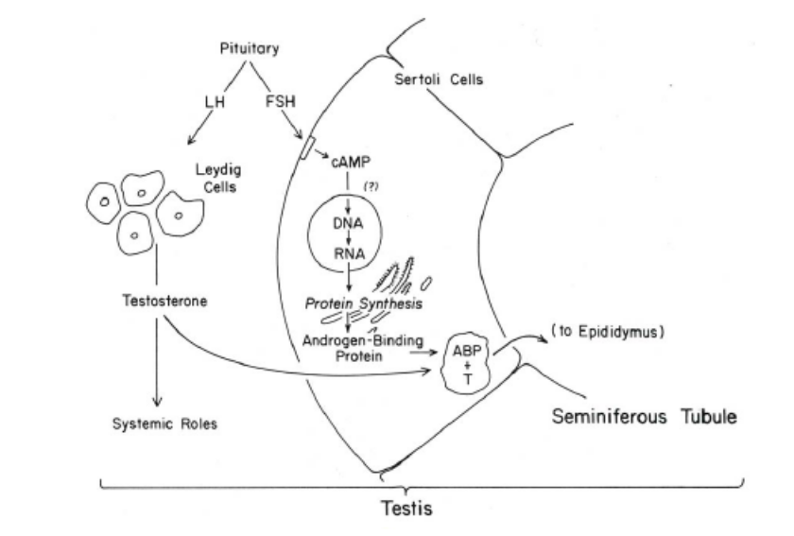
  - Initiation of this process occurs at puberty as a result of an elevation in androgen levels.
- The gonadotropins cooperate to facilitate sperm development and peripheral secondary sex tissue development and function.
  - The pituitary gland releases FSH and LH.
  - LH stimulates the Leydig cells to secrete testosterone. Testosterone then travels across the membrane into the Sertoli cells.
- FSH stimulates the Sertoli cells to produce more androgen-binding protein. This androgen-binding protein binds testosterone and brings it from the Sertoli cells to the epididymus.

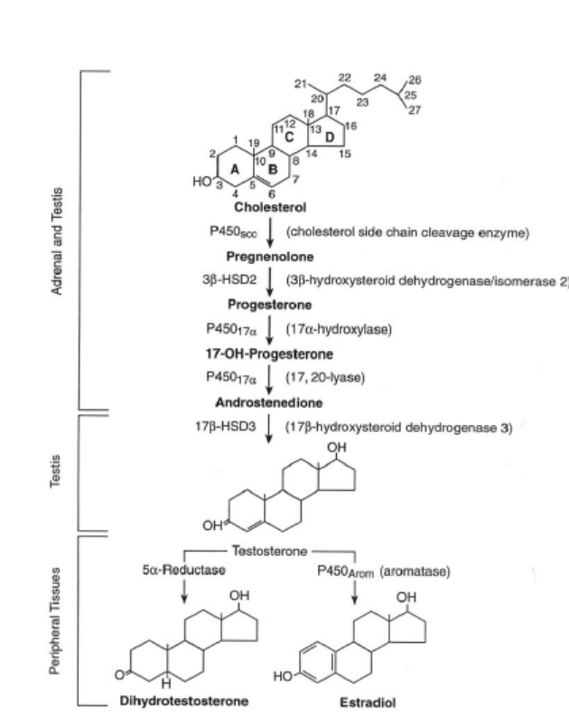
- The LH-Responsive Leydig cells are the source of testicular androgen.
  - The Leydig Cells convert cholesterol to testosterone through the process outlined in the diagram on the right.

- It is important to note that there is a hierarchy in the steroid hormones.
  - Cholesterol is the least biologically active but has the highest concentration.
  - Estrogen is the most potent but has the lowest concentration.
- Androgens are required for spermatogenesis.
  - However, androgenic steroids bring spermatogenesis to a halt due to negative feedback on the testes. It also causes liver problems, as the liver is responsible for metabolizing steroids.

- Inhibin and Activin: (these are both part of the TGF-β Family) Activin forms β-subunit homodimers, whereas inhibin forms heterodimers.
  - Inhibin is a heterodimeric hormone which inhibits FSH secretion.
  - Activin stimulates FSH secretion (although it is inhibited by follistatin).

- Male Contraceptives: So far there has been no success in the attempt to make a male contraceptive. The ideas so far have been:
  - Anti-androgens: (e.g. cyproterone acetate). However the side effects of this are a decreased libido and 2° sex tissue atrophy.
  - Anti-androgen + Estrogen: This caused gynecomastia (development of breasts)
  - LHRH Antagonists: These present the same problems as anti-androgens.
  - Drugs that block mitosis (gossypol): Gossypol is found in cotton. It can prevent the mitosis of cells. However the toxicity range and the effectiveness range for the dosage of gossypol overlap and therefore it is impossible to use this drug as a contraceptive.

PATTERN OF SECRETION IN PRE-PUBERTAL MALE

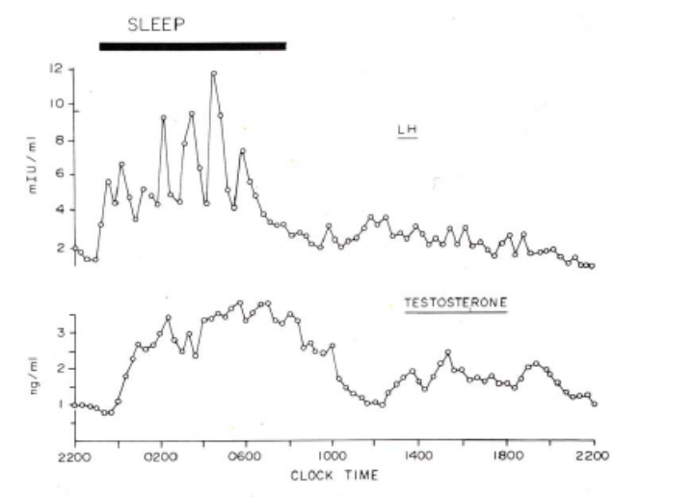
- In the pre-pubertal male, we see a higher level of secretion during sleep.

- In the post-pubertal male, the sleeps versus awake secretion levels equalize.
  - Instead, there is a low level of LH pulsing occurring throughout the day and night.

PHGY 311 - Lecture 29 November 24, 2006
Writer: Steph Rolin Dr. Farookhi

SUGGESTIONS
- Dr. Farookhi skipped quite a few slides. However, we are still responsible for that material so please review it.
- In addition, make sure to do the readings BEFORE class.
- Any questions asked on the slides are yours to answer.

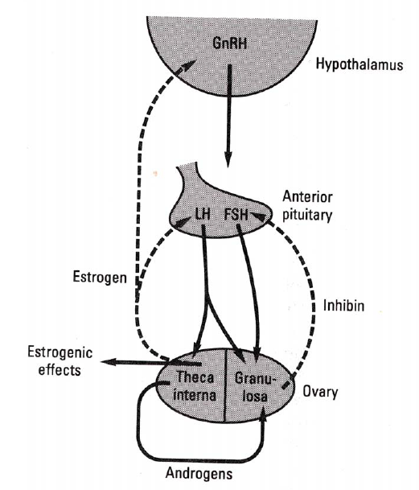
HYPOTHALAMO-HYPOPHYSIAL-OVARY AXIS
- The hypothalamo-hypophysial-ovary axis consists of the hypothalamus, anterior pituitary, and the ovaries.
  - This is very similar to the male axis.

- GnRH released from the hypothalamus impinges on the anterior pituitary, causing the release of LH and FSH.
- LH and FSH are gonadtropins that act on 2 separate compartments of the ovaries.
  - LH acts on the theca interna cells, FSH acts on the granulosa cells.
    - Note: Just before the follicle is ready to be released, LH will also have an impact on the granulosa cells. These cells will then develop LH receptors.

- The axis consists of classical negative feedback.
  - Estrogen (from theca interna cells) has negative feedback on the anterior pituitary and the hypothalamus.
  - Inhibin (from granulosa cells) feeds back negatively on the anterior pituitary.
- Note parallel between male and female axis.

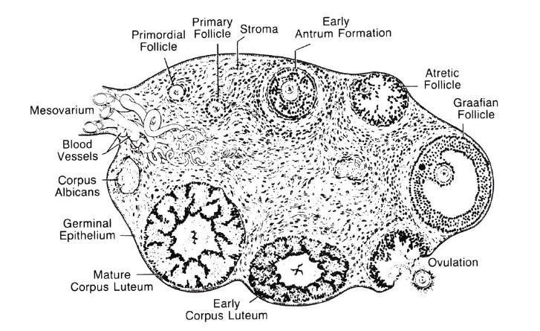
STRUCTURE OF THE MAMMALIAN OVARY
- The ovary is a kidney-shaped structure.
  - Surrounded by ovarian surface epithelium. This is the major source of ovarian cancer in humans.

- It has two major endocrine tissues, the follicle and the corpus luteum.
- Follicles exist at various stages of development.
  - Primordial follicle—oocyte, surrounded by a single layer of granulosa cells.
  - Primary follicle—oocyte, surrounded by a single layer of cuboidal granulosa cells.
  - The follicle eventually becomes a Graafian follicle.

- Once the Graafian follicle has been formed, ovulation will occur as a result of an LH surge.
  - This is the signal that will cause ovulation. The egg will be released and the follicle differentiates, becoming a corpus luteum.

OOCYTES
- Oocytes are primordial germ cells that originate from an area, the proximal epiblast, adjacent to the extraembryonic ectoderm.
  - Don’t originate in the gonads.
- BMP4, a member of the TGF-Beta family, will cause cells in the ectoderm to differentiate. These cells become primordial germ cells and then migrate to the genital ridge.
  - We can identify these cells as they have high alkaline phosphatase activity.

- Once cells arrive at the genital ridge, they proliferate.
  - For humans, this massive proliferation results in 4-5 million oocytes per ovary.
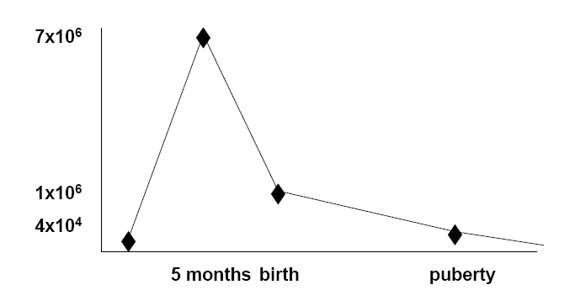
- Once migration is complete, you get massive degeneration.
  - The majority of oocytes are destroyed. At birth, a human female has .5-1 billion oocytes left. At puberty, she has only 40-60,000 oocytes.
    - A maximum of 500 or 600 oocytes will be ovulated.

- So there is a large-scale loss of oocytes throughout a female’s lifespan.
  - Females cannot regenerate germ cells, unlike males. What she has available at puberty is all she has.

INITIATION OF MEIOSIS
- Mitotic proliferation stops during late embryogenesis.
  - Oocytes enter meiosis, advance to the diplotene/dictyate of prophase I.
    - They have replicated their DNA, but not yet separated. They are still diploid and will remain here until the time they are ovulated.
- So oocytes are arrested in meiosis from the time of fetus (late embryogenesis) until the time they are ovulated (could be 45-50 years later).
  - Since the oocytes are suspended in a state of arrested meiosis for so long, it is not surprising that women who have children later in life have a great probability of having a child with some sort of abnormality.

OOCYTES AND GRANULOSA CELLS
- The follicles are formed in the ovary by the granulosa cells surrounding the oocytes. They sit here until, every once in a while, one of them begins growing.
  - We don’t know what the signal initiating this growth is.
It’s somehow based on the number of oocytes present, but we don’t understand more than that.

- Granulosa cells are required for oocyte growth.
  - Intimate conversation is necessary between the granulosa cells and oocytes, in order for proper development to occur.
- Communication between the oocyte and the granulosa cells surrounding it occur through gap junctions utilizing connexin-37.
  - If you knockout connexin-37 in a mouse, the follicle will develop to the antral stage. But, the oocyte will not proceed any further in response to the LH-surge.
    - Oocyte does not acquire meiotic competence.

- Granulosa cells are connected to each other through gap junctions that utilize connexin-43.
  - In a knockout mouse, there are few germ cells, as the oocytes degenerate because they are not properly protected by the granulosa cells.
    - Suggests that connexin-43 is involved with allowing granulosa cells to gather properly around the oocyte. If the granulosa cells don’t do this, the oocyte is not protected and could degenerate.
  - In addition, in this knockout mouse, follicles fail to develop beyond primary stage. Oocytes will not be fully grown and will not acquire meiotic competence.

FOLLICLE GROWTH
- Follicle growth involves enlargement of the oocyte, ganulosa cell proliferation, differentiation, and tissue reorganization.
- The primordial follicle (formed in embryo) becomes a primary follicle when the granulosa cells become cuboidal. At the same time, the oocyte enlarges and there is further proliferation of the granulosa cells.
  - End result is a Graafian follicle, an oocyte with a layer or two of granulosa cells, and then an outside granulosa membrane.

- Then the LH surge occurs, causing ovulation.
  - This structure breaks down and the ovum is released. The structure now forms a corpus luteum, which secretes estrogen and progesterone.
    - The role of the corpus luteum is to prepare the uterus from pregnancy.

- The whole development of the follicle—prior to the formation of the antrum—will occur in animal whose pituitary has been removed.
  - Independent of LH and FSH.
- Gonadtropins are only necessary to reach the antrum stage and proceed beyond it.
  - The granulosa cells have FSH receptors and the theca cells have LH receptors. However, if you don’t have FSH or LH, you can’t form an antrum.

STEROID SYNTHESIS
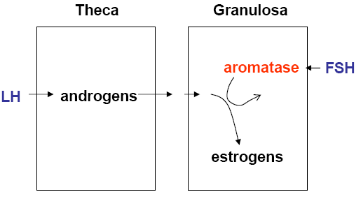
- The ovary has two separate compartments, the theca and granulosa cells.
  - These compartments cooperate with one another to see that estradiol is made.
- LH, acting on the theca compartment, generates androgens.
- Androgens then diffuse into the granulosa cells, where it is converted to estrogen.
  - FSH facilitates this as it is turning on the gene for aromatase and generating aromatase.

- The first step of steroid synthesis is converting cholesterol to pregnenolone. Eventually, this is converted to androgen. Once androgen has been turned into estrogen, it can’t be reversed.
  - Notice the direction of arrows during steroid synthesis. Some steps are reversible (estrone←→estradiol) but others are not (testosterone→estrogen).
    - Can’t go backwards from an aromatized steroid to an androgen.

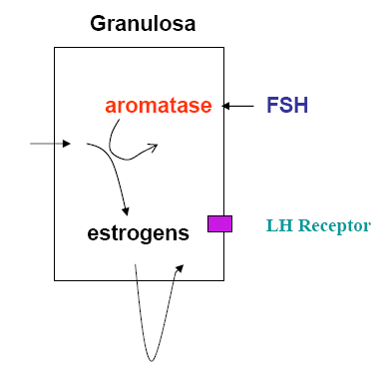
- Then, once estrogen has been produced through the cooperation of the theca and granulosa compartments, the granulosa cells near the basement membrane (not the ones surrounding the oocyte) use estrogen and FSH to induce LH receptors.
  - Now these granulose cells have LH receptors. everything was waiting for the induction of LH receptors.

LH SURGE
- By convention, we refer to the day of the LH surge as day 0 of the menstrual cycle.
  - LH and FSH levels are surging at the same time, so GnRH levels must be surging at the day time. at this point, there is an unexplained failure of the negative feedback cycle.
    - Don’t know why this occurs.
- There is no lag between the LH and FSH surges, as LH receptors have been induced beforehand. These receptors must be in place in order for the surge to occur.

- As a consequence of the LH surge, ovulation occurs. The ovum is released, and the corpus luteum is formed.
  - The corpus luteum begins producing progesterone and estrogen.

- As mentioned, it is not clear why the LH surge occurs. What is known is that in order for this to occur, you need an elevation of estrogen. Other than that, although there has been a lot of study (and theories), the underlying mechanism for the positive feedback leading to the LH surge remains unknown.
  - Some say modulation occurs in the brain that gives rise to alterations in inhibitory feedback. This is true, but it doesn’t explain everything.
  - Also, there are changes in LHRH pulsatility under different steroidal conditions.
    - In an estrogen-dominated state (when the follicle is making estrogen), there are high frequency pulses of LHRH. What seems to be happening is that high frequency pulses causing increased synthesis of LH and FSH, but their release is inhibited.
      - Massively building up levels of LH and FSH. Pushing synthesis while clamping release. The system bursts, and then there is a massive discharge of LH and FSH.
    - In a progesterone-dominated state (after ovulation), the frequency and amplitude of LHRH pulses is altered. This has negative feedback on progesterone and estrogen. It is thought that the pituitary is capable of reading and interpreting different pulse frequencies and amplitudes.

SECONDARY SEX TISSUES
- Females have two secondary sex tissues, the mammary glands and the uterus.
  - Both tissues respond to steroids in similar manners.
- Recall that the corpus luteum is releasing progesterone and estrogen. These steroids act on the uterus, preparing it for pregnancy.

- Estrogen stimulates the endometrial cells of the uterus and causes proliferation.
  - Estrogen is very potent. It will cause a number of different cells to proliferate.
  - This proliferation gives rise to an endometrial layer in the uterus that can respond to progesterone.
- Once the corpus luteum has been formed, it will release progesterone. Progesterone will act on the uterus and cause it to differentiate such that it will be capable of accepting the implantation of a fertilized egg.

- If pregnancy does not occur, after about 7 days, when the corpus luteum is halfway through the luteum phase, it will begin to decrease progesterone secretion.
- Lutelysis begins to occur, the endometrium sloughs off, and this is the menses.
  - Menstruation is unique to primates. Other species don’t show menstruation—they reabsorb the endometrial layer.
LHRH RHYTHM
- Recall the pre-pubertal male: he exhibited a pattern of LH secretion that was elevated at night, lower during the day. We see exactly the same thing in a pre-pubertal female.
  - During sleep, there is an increase in LH levels. This is being driven by an increase in LHRH.
  - At the end of the day, there is a low, flat level of LH, corresponding to a low, flat level of LHRH.
- There is some dependence on REM sleep.
  - A sleep-deprived individual’s reproductive system shuts down.

- After puberty, this cycle disappears. Instead, there are pulses throughout the day and night.

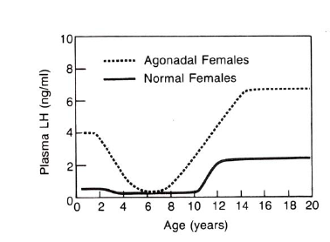
- The female is waiting for puberty. This cycle seems to be a way of priming the system.
  - Ovaries are ready at any time. She is waiting for the brain to be ready. We know this because an agondal female (a female with no ovaries) experiences the same relative changes in plasma LH levels, including a resetting of levels that occurs during puberty.
    - Not dependent on the gonads. The control for this reset is higher up, somewhere in the brain.

- The initiation of puberty is dependent upon reaching a critical fat mass.
  - An anorexic pre-pubescent female will not do through puberty as she will never reach this critical fat mass.
  - The age of puberty is decreasing because females are reaching this point earlier on, at about 9-10 years of age (instead of 14-15).

- During the lifecycle of a female, she undergoes different rhythms.
  - During the pre-pubertal period, there is a nighttime elevation of GnRH, FSH, and LH.
    - Priming the system, preparing it to turn on.
  - Once she has gone through puberty, cyclicity starts.
  - A postmenopausal woman has increased LH and FSH levels.
    - As the number of follicles left decreases, less and less estrogen is produced. The negative feedback cycle is broken and there is elevation of FSH and LH levels.

FERTILIZATION
- Fertilization occurs in the female reproductive tract, in area called the ampulla.
  - The fimbriae scoop up the ovum that’s been ovulated and transport it to the ampulla.
- Meanwhile, the sperm are deposited in the vagina. They are transported, via the beating of the cilia of the female reproductive tract, to the ampulla.
  - It is NOT the swimming ability of the sperm that transports the sperm up the ampulla. The female transports everything using cilia.
    - If small charcoal particles are deposited in the cervical area at the time of ovulation, they will be transported up to the ampulla.
- However, the swimming ability of the sperm is critical for the fertilization of the egg.
  - Need viable motile sperm in order for fertilization to occur.

PHGY311 - Lecture 30 November 27, 2006
Writer: Natasha Fernando Dr Farookhi

Sample question
Gonadocyte Inc. has shipped pure isolated [adult] Sertoli, Leydig, granulose and theca cells to your laboratory. Unfortunately, the labels were washed off. Outline specific tasks (eg hormone synthesis, receptors, etc) to identify each cell.

NOTE: The size and morphology are inconsequential because isolated cells look a lot like each other.

- First, separate the cells using LH and FSH.
  - Leydig and theca cells respond to LH.
  - Sertoli and granulosa cells respond to FSH.

- Now, in order to separate Leydig cells from theca cells, determine which sample has a Y chromosome. This would be the Leydig cell sample.
- Do the same to distinguish the Sertoli and granulosa cells.

Note: It is important to know sexual development and not compartmentalize information from each lecture. We have to integrate our knowledge from all chapters.

Fertilization
- A surge in LH has caused the egg to be released, thus initiating the resumption of meiosis.
  - The oocyte will now go through its first meiotic division, sheds half of its DNA into the first polar body and the process stops for now.
- The oocyte now waits for fertilization which will result in the second division of meiosis.
  - The oocyte is technically never haploid.

- In order for the sperm to fertilize the egg, the sperm has to undergo capacitation, which is the stripping of proteins off the sperm head.
  - This occurs in the female reproductive tract.
- Sperm capacitation can also be done in vitro by exposing the sperm to albumin or serum.
  - This is how in vitro fertilization is carried out

- There is an elaborate process for blocking polyspermy, ensuring that an egg is only fertilized by a single sperm. Blockers exist in:
  - The cumulus cells around the egg
  - The accellular membrane around the egg, called the zona pellucida (ZP)
  - The plasma membrane of the oocyte
- The spermatozoa have set of enzymes that allow it to digest and penetrate the zona pellucida and finally make contact with plasma membrane.
  - The moment sperm comes into contact with the plasma membrane, there is a discharge of cortical granules. It is believed that there are receptors for sperm on the plasma membrane.
- The discharge of cortical granules results in the removal of these plasma membrane receptors and there is cross-linking of the zona pellucida so that the rest of the sperm cannot penetrate.
  - Consequently, only one sperm head will be endocytosed within the oocyte and will contribute its DNA content.

- The oocyte now undergoes its second meiotic division and becomes a diploid cell, resulting in a 1 cell embryo. The male and female pronuclei cross over and development continues.

- Another contributor of DNA is the mitochondria. In humans, there is no mitochondrial contribution from male. All our mitochondria is maternal.
  - This is useful for evolutionary tracing.

Zona pellucida
- The zona pellucida is made up of glycans, a type of glycoprotein.
  - There are 3 components to the zona pellucida called ZP 1, ZP 2 and ZP 3.
- ZP 3 is believed to be a receptor for spermatozoa. With contact, there is an acrosome reaction which releases enzymes that digest the zona pellucida.
  - Following this is the discharging of cortical granules, mentioned above. This system of blockers works, and the incidence of polyspermy is low.

Embryo implantation
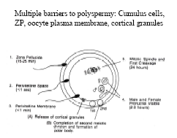
- The 1 cell embryo divides on its way to the uterus. Multiple divisions occur, and finally there develop a little cavity within the embryo, thus forming a blastocyst.
  - Upon arriving at the uterus, the embryo is still at the blastocyst stage but within the zona pellucida. This means that the dividing cells are much smaller since they are enclosed within the same zona pellucida

- Once the embryo ‘hatches’ from the zona pellucida, it gets implanted onto the uterus, provided it is ready.

- It is believed that the embryo secretes a signal that affects directionality.

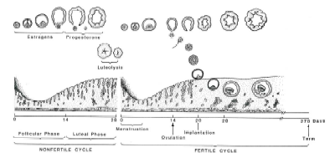
Implantation
- The graph of the uterus lining shows its stages.
- The estrogenic phase causes mitotic proliferation of the endometrium.
- During the luteal phase, corpus luteum stimulates progesterone secretion which causes differentiation of the endometrium, such that glandular cells are formed.

- It is VITAL that estrogen is followed by progesterone. If there is only progesterone present, you will not get implantation. Estrogen is needed first because it induces progesterone receptors.

- If the uterus wall did not receive a fertilized egg, the corpus luteum will degenerate and the endometrium will be sloughed off (menstruation).
- If fertilization does occur, for a short time, the corpus luteum will receive an hCG signal, preventing it from degenerating.
  - Human chorionic gonadotrophin (hCG) is a glycoprotein. It looks like FSH, TSH and LH. It is heavily glycophosphorylated so it has a long half-life.

- The corpus luteum has receptors for LH, which looks a lot like hCG. When the corpus luteum is sustained, progesterone is secreted so that pregnancy can continue.
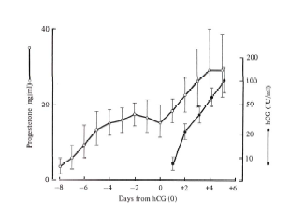
hCG and Progesterone
- hCG production and progesterone production start from the time of implantation (t=0)
- For the first 6 or 7 days, the corpus luteum is only making progesterone.
- Upon differentiation of the cell, the corpus luteum now becomes LH dependent. It will degrade if it does not receive the appropriate signal.

Implantation
- Ectopic pregnancies occasionally occur in places like the oviduct because the fertilized egg does not give the right signal.
  - It is also possible for the egg to go through the perineal cavity and implant in the liver, gut or ovary. There will be an attempt to form placenta with the invasion of trophoblast cells which is dangerous for the mother.

- If implantation occurs in the uterus, trophoblast cells will invade uterine cell lining and the embryo will contribute to placenta formation. Both the trophoblast and residual cells contributed by the mother.
  - Implantation occurs within 6 or 7 days of fertilization.

The Mother-Fetus Relationship
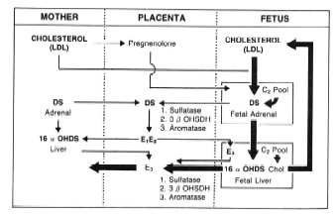
- There is a symbiotic relationship between the mother and fetus. There are extensive interactions between the two compartments, indirectly through the placenta.

- The placenta does not have the 17-alpha hydroxylase enzyme. Its function is to convert progesterone to androgens.
  - Both the fetus and the mother have this enzyme in their adrenal glands.
- hCG stimulates progesterone production from the corpus luteum but the corpus luteum is not required after first trimester because the placenta takes over as source of progesterone.
- So, cholesterol is converted to prenenolone in placenta. This is then shunted to fetus and mum and converted to androgens. The androgens are shunted back and converted to estrogen.

Note: If took out the ovary from human female after first trimester, she would still be able to maintain pregnancy because there is no longer a dependence on the corpus luteum, which lies in the ovary.

Parturition
- It is not know what initiates normal parturition in human females, although it can be induced with oxytocin.
- It is known that the signal is of fetal origin in the neuronal tissue.
  - In cases of hydrocephaly (water in the brain), these fetuses have a much longer gestation period.

- In most mammals there is a loss of progesterone from placenta, thus initiating parturition. Oxytocin and relaxin are also involved in parturition and they are secreted from the hypothalamus.
  - Oxytocin acts on oxytocin receptors in the uterus, causing contractions.
  - Relaxin helps to widen the birth canal.

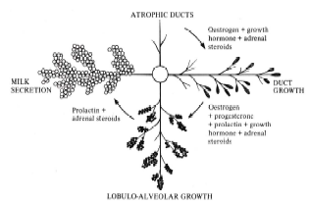
Lactation
- Lactation requires higher energy than pregnancy. The mammary glands are source of nutrition for the newborn.
- Mammary gland growth:
  - Skinny ducts in prepubertal females undergo differentiation and duct growth resulting from estrogen (at the onset of puberty).
  - Proliferation of these ducts occur. In a pregnant female, progesterone causes the mammary glands to differentiate further such that the cells at the edges of the ducts become secretory.

- There is nothing special about female mammary glands. It depends on what they’re exposed to that will drive differentiation.
  - Thus if males were given estrogen (or estrogen-like substances such as marijuana) and progesterone, they would develop mammary glands.

Prolactin
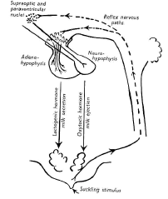
- Estrogen and progesterone drive mammary gland differentiation.
- For milk secretion, you need prolactin and oxytocin, which are released through a reflex arc.
  - The suckling stimulus is transmitted through the spinal cord to the supraoptic and paraventricular nuclei which it will cause secretion of oxytocin.
  - This reflex arc will impinge on the hypothalamus, inhibiting dopamine which releases the inhibition of prolactin secretion.

- Prolactin acts on differentiating glandular cells, synthesizing milk constituents.
- Oxytocin causes ejection of milk through the duct system.
  - There are smooth muscle cells around the mammary gland. They have oxytocin receptors. In the presence of oxytocin, the smooth muscle cells will contract around the alveolar cells to eject milk.

Milk synthesis
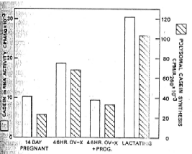
- There is steroid modulation of milk synthesis. Human placental lactogen has growth hormone and prolactin-like activities.
  - It stimulates the mammary glands to start milk production but milk is not secreted when the female is pregnant.
- In the graph, it shows translatable casein RNA and total RNA proteins. If you ovarectomise a rat, casein RNA goes up and total casein goes up.
  - This implies that there is something in the ovary that suppresses the generation and translation of milk proteins.
- This suggests that progesterone is present in the mother’s circulation but it suppresses prolactin. With the removal of placenta, prolactin is no longer suppressed and milk secretion can occur.

Immunoglobulins in Breast Milk
- Breast milk contains the immunoglobulin A class.
  - Rodents lick the anal-genital area of their newborn to immunize themselves with coli-bacteria from the newborn.
- The mother will build up an immune response and transmit it to the newborn. This proves that close contact with newborns allows for immunization to occur.

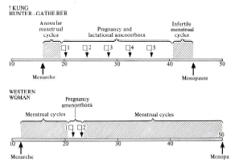
Prolactin Interrupts Cyclicity
- Prolactin inhibits cyclicity by inhibiting LHRH secretion from hypothalamus and by blocking the induction of the aromatase enzyme.
  - It is a natural form of birth control.
- Since this requires sustained levels of prolactin, for this to be the case there has to be suckling for a length of time.

Mammary Carcinoma
- In general, pregnancy protects against mammary carcinoma, however late-in-life pregnancies do not.
- In addition, uninterrupted menstrual cycles are a risk factor for this.
  - Each cycle, there is a substantial amount of proliferation that just stops suddenly. This can have a bad effect on the female in the long run.

